Marking a Deck of Bicycle Brand Cards:

Written by Andrew A for howtomarkcards.com

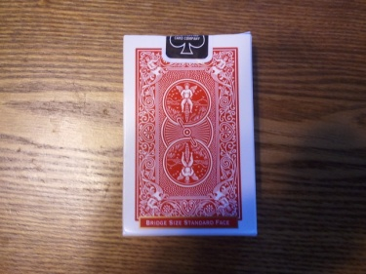These simple directions will get you through creating a deck of marked Bicycle cards:

You will need:

Red fine tip Sharpie

Deck of Red backed Bicycle brand cards

1. Separate each suite so you have 4 piles of 13 cards each.
2. C:\Users\andies9488\AppData\Local\Microsoft\Windows\Temporary Internet Files\Content.IE5\ME2T4Q53\MC900383668[1].wmf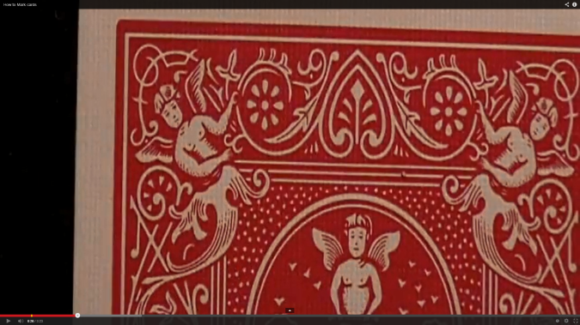Refer to picture below: There are 5 white dots to the right of the person in the corner of the design.

We will only be using the first 4. This is going to make the suite stand out. I usually do alphabetical order for the suites so Club, Diamond, Heart, and Spade is the order. First white dot represents the Club, second white dot is the Diamond, so on. Take the red sharpie and color in the first white dot for all 13 clubs. Then color in all the second white dots for diamonds and so on. Now you have marked all 52 cards with the suites. Tip: Only mark the top right dot and flip the card then mark that top right dot. There should only be 2 corners marked.

1. Refer to the picture below: The white pedals that make out a flower will determine the card. These pedals are to the left of the person in the design.

C:\Users\andies9488\AppData\Local\Microsoft\Windows\Temporary Internet Files\Content.IE5\Y21HYUDA\MC900383666[1].wmf

So now I will explain what each pedal means:

Ace: Blank, no pedal colored

2: Top north pedal colored in (12 O’Clock)

3: The next pedal to the right colored in.

4: The Eastern right pedal colored in (3 O’Clock)

5: The very next pedal to the right of that

6: The bottom south pedal colored in (6 O’Clock)

7: The next pedal clockwise to that colored in

8: The Western left pedal colored in

9: The next clockwise pedal colored in

10: The center dot colored in

Jack: The center dot and north pedal colored in

Queen: The center dot and same pedal as 3 colored in.

King: The center dot and eastern right pedal colored in.

Now that you know everything you need to know about marking the red backed bicycle brand deck of cards, memorize the method so you do not have to think twice on which card is marked!

Tip: Memorize the suite order so that there is no thinking when you see that card in action!